Logistic Regression

Linear regression is a Regression technique

Logistic regression is classification technique

Use case:

You are a magazine owner, you want to know the subscription of your magazine based on age criteria

Target column: magazine subscription

Input column: age

| Age | Sunscribe(y) |
| --- | --- |
| 30 | Yes |
| 35 | No |
| 40 | No |

Assume that you know only Linear regression, you doesn’t know any classification methods

$subscribe=b_{0}+b_{1}*age====(1)$

$what is the draw back in above equation?$

${RHS: b}_{0}+b_{1}*age=======always numbers$

$LHS: subscribe is nothing but yes or no$

$that^{'}s why we can^{'}t represent classification use cases with regression formulae$

$subscribe is yes or no, so i will not use subscribe directly$

$p\left(subscribe\right)=b_{0}+b_{1}*age========(2)$

$classification problem two lables yes and no$

$when you pass a test input to the model , it will give the predictions either yes or no$

$before provide yes or no, first the model will give probability values for yes and no case$

$what is the chance to get output as yes: p\left(yes\right)$

$what is the chance to get output as no:p(no)$

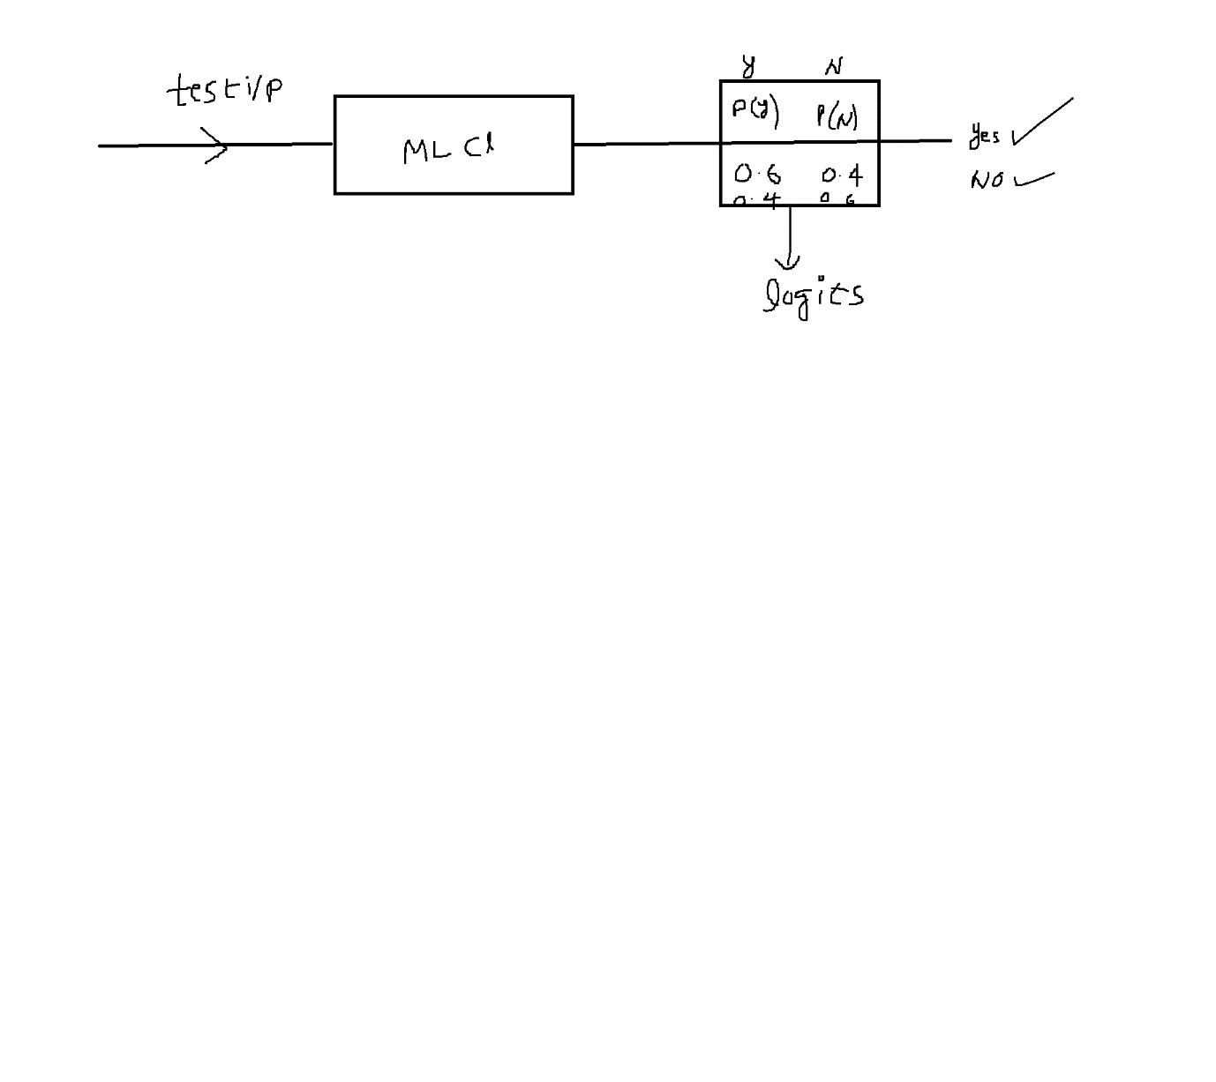

$subscribe=b_{0}+b_{1}*age=======\left(1\right)$

$p\left(subscribe\right)=b_{0}+b_{1}*age=====(2)$

$0.5+0.2*30=0.5+6=6.5 RHS$

$p\left(subscribe\right) =0 max=1$

$LHS range between 0 to 1$

$RHS range between -infinf to +inf$

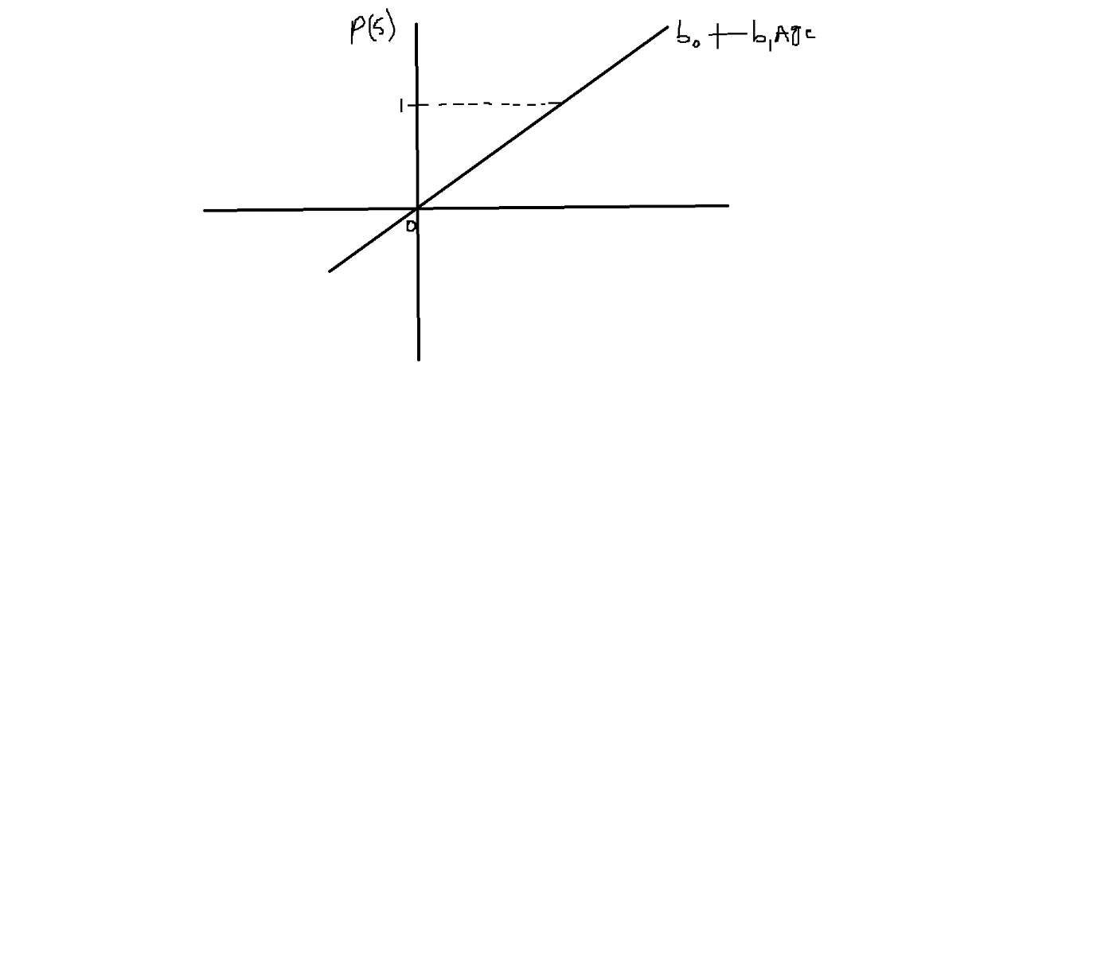

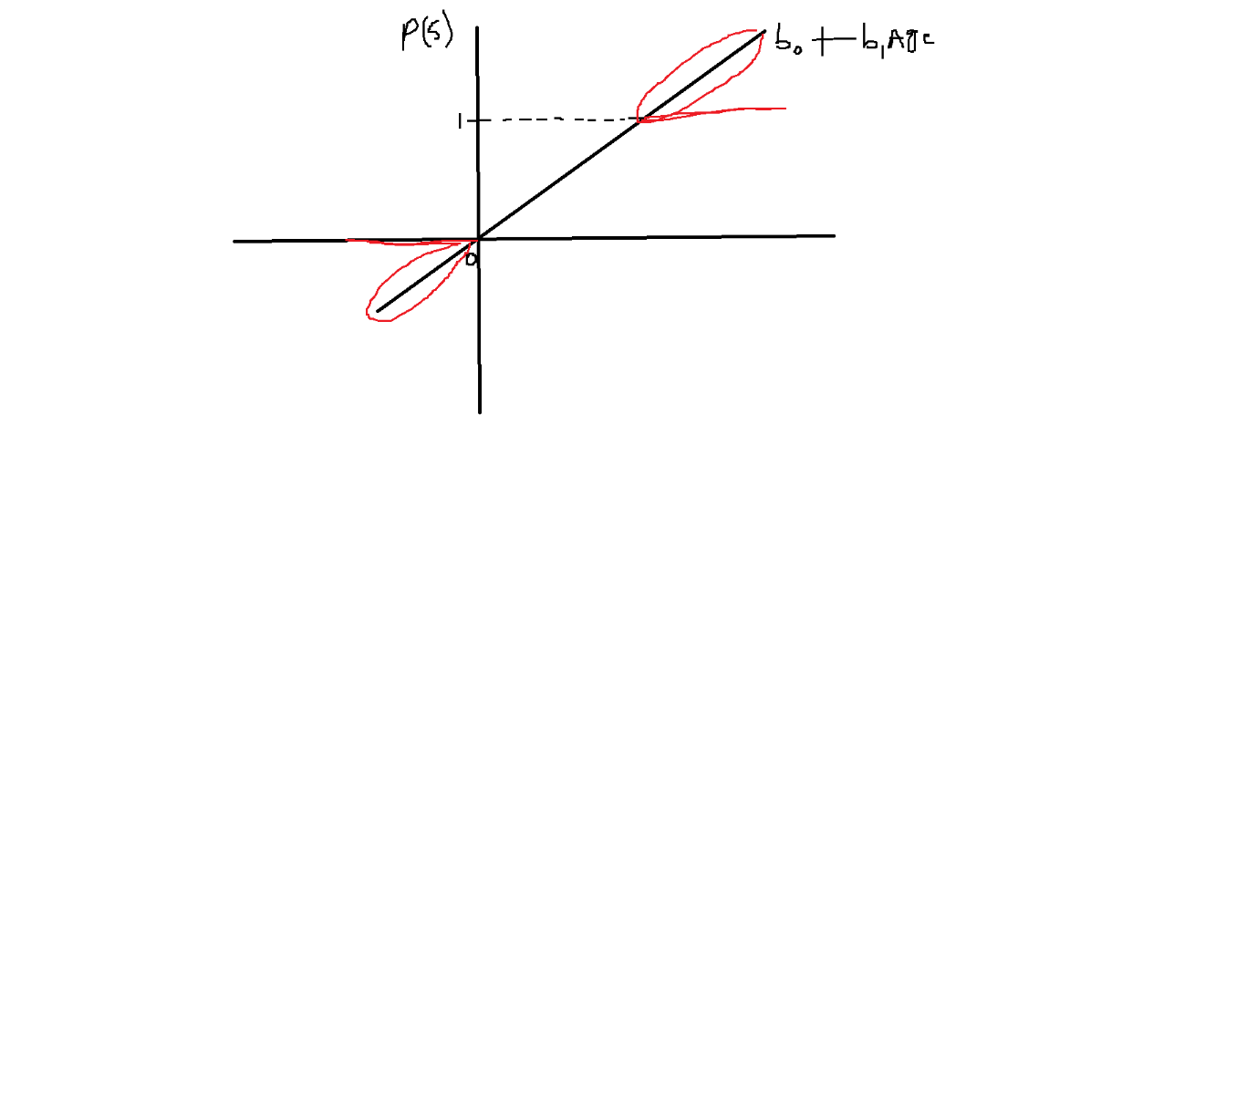

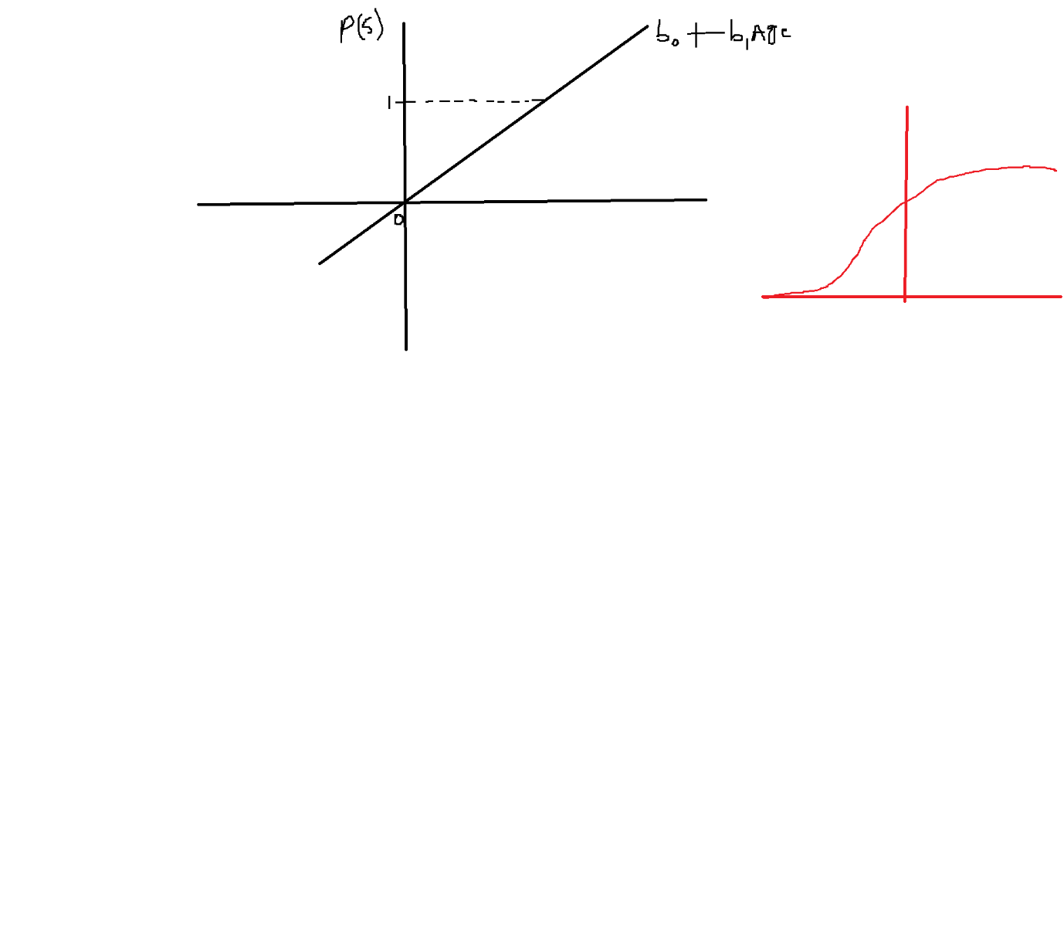

$p\left(subscribe\right)=b_{0}+b_{1}*age$

$b_{0}+b_{1}*age RHS equation to 0 to 1$

Sigmoid function values ranges between 0 to 1 only

$sigmoid\left(z\right)=σ\left(z\right)=\frac{1}{1+e^{-z}}$

$sigmoid\left(x\right)=σ\left(x\right)=\frac{1}{1+e^{-x}}$

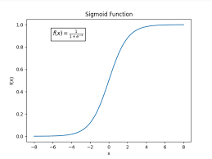

$p\left(subscribe\right)={sigmiod(b}_{0}+b_{1}*age)======(3)$

$subscribe=b_{0}+b_{1}*age======\left(1\right)$

$p\left(subscribe\right)=b_{0}+b_{1}*age======(2)$

$p\left(subscribe\right)={sigmiod(b}_{0}+b_{1}*age)======(3)$

$sigmoid\left(x\right)=σ\left(x\right)=\frac{1}{1+e^{-x}}$

$p\left(subscribe\right)=\frac{1}{1+e^{-{(b}_{0}+b_{1}*age)}}$

$p(y)=\frac{1}{1+e^{-{(b}_{0}+b_{1}*x_{1}+b_{2}*x_{2}+….+b_{n}*x_{n})}}$

$classification problems either bi-classification and multiclassification$

$bi-classification:target variable has two lables yes or no$

$p(y=yes)=\frac{1}{1+e^{-{(b}_{0}+b_{1}*x_{1}+b_{2}*x_{2}+….+b_{n}*x_{n})}}$

$p(y=no)=\frac{1}{1+e^{-{(b}_{0}+b_{1}*x_{1}+b_{2}*x_{2}+….+b_{n}*x_{n})}}$

Probability of getting head =0.5

Probability of getting tail =0.5

$sigmoid\left(x\right)=σ\left(x\right)=\frac{1}{1+e^{-x}}$

$case-1: x=0$

$sigmoid\left(0\right)=σ\left(0\right)=\frac{1}{1+e^{-0}}=\frac{1}{2}=0.5$

$case-2: x=-inf$

$\frac{1}{1+e^{-x}}$

$\frac{1}{1+(\frac{1}{e^{x }})}$

$\frac{(e^{x})}{{(e}^{x}+1) }$

$\frac{1}{1+e^{-x}}=\frac{e^{x}}{1+e^{x}}$

$sigmoid\left(-inf\right)=σ\left(-inf\right)=\frac{1}{1+e^{-x}}=\frac{e^{x}}{1+e^{x}}$

$e^{-inf}=0$

$\frac{e^{-inf}}{1+e^{-inf}}=\frac{0}{1+0}=0$

$case-3: x=+inf$

$sigmoid\left(inf\right)=σ\left(inf\right)=\frac{1}{1+e^{-x}}=$

$\frac{1}{1+e^{-inf}}=\frac{1}{1+0}=1$

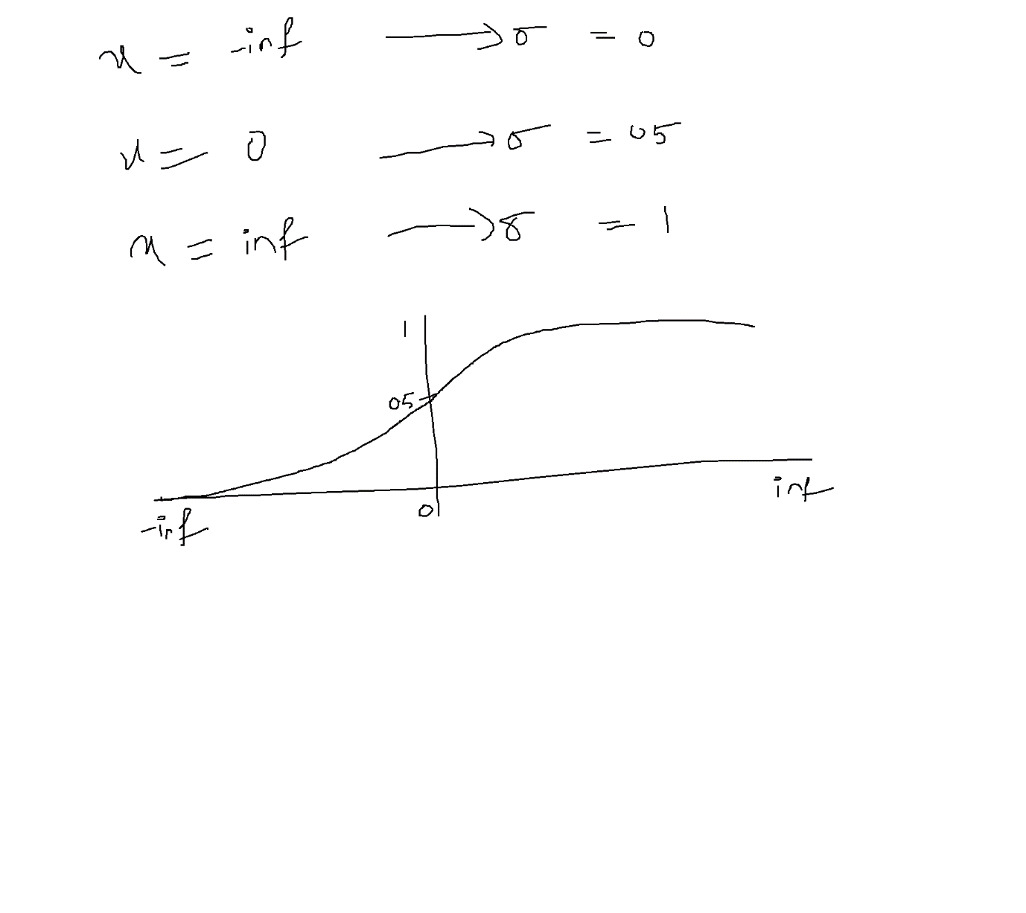

$p(y)=\frac{1}{1+e^{-{(b}_{0}+b_{1}*x_{1}+b_{2}*x_{2}+….+b_{n}*x_{n})}}$

$p\left(y\right)=\frac{1}{1+e^{-{(b}_{0}+b_{1}*x_{1})}} (in simple way)$

$y=b_{0}+b_{1}*x_{1}=====Simple linear regression$

${what is interpreation: b}_{1}$

$if x is incease by one unit y is incresase by b1 times$

$p\left(y\right)=\frac{1}{1+e^{-{(b}_{0}+b_{1}*x_{1})}} interpreate b_{1}$

$only linear equations can be interprateable, non linera equation can^{'}t interprate$

$sigmoid function is non-linear equation , we can^{'}t interpreate$

$p\left(y\right)=\frac{1}{1+e^{-{(b}_{0}+b_{1}*x_{1})}}$

${k=b}_{0}+b_{1}*x_{1}$

$p=\frac{1}{1+e^{-k}}$

$p(1+e^{-k})=1$

$p+p*e^{-k}=1$

$p*e^{-k}=1-p$

$e^{-k}=\frac{1-p}{p}$

$e^{k}=\frac{p}{1-p}$

$k=log⁡(\frac{p}{1-p})$

$b_{0}+b_{1}*x_{1}=log⁡(\frac{p}{1-p})$

$loglog \left(\frac{p}{1-p}\right) =b_{0}+b_{1}*x_{1}=======(4)$

$loglog \left(\frac{p}{1-p}\right) =loglog odds ratio$

$if we increase x by 1 unit then loglog odds ratio will be incresae by b_{1} times$

$subscribe=b_{0}+b_{1}*age=======\left(1\right)$

$p\left(subscribe\right)=b_{0}+b_{1}*age=====(2)$

$p\left(y\right)=\frac{1}{1+e^{-{(b}_{0}+b_{1}*x_{1}+b_{2}*x_{2}+….+b_{n}*x_{n})}}===(3)$

$loglog \left(\frac{p}{1-p}\right) ={(b}_{0}+b_{1}*x_{1}+b_{2}*x_{2}+….+b_{n}*x_{n} (4)$

$to get equation 3 , we need sigmoid function$

$we are not able to interpreate equation-3,$

$we modified to equation-4$

$start with sigmoid function and land up equation-3$

$learn modifcation maths , then land up equatin-4$